PURPOSE:
The purpose of the procedure is to describe how carry out pigging in an operating pipeline.

SCOPE:
This procedure shall be applicable to all sections of IOCL pipeline.

REFERNCES:
- Latest approved Pigging Strategy (M&I- PLHO)
- SOP NO: SP/ML/19: Procedure for Pig Launching
- SOP NO: SP/ML/20: Procedure for Pig Receiving
- SOP NO: SP/ML/40: Procedure for Pig Residue Analysis
- SOP NO.: SP/ML/26: Procedure for Assessment and repair of dent
- Respective Operation Manual of the station
- OEM’s Manual of Pig Launcher/ Receiver supplier
- HSE manual (IOCL-PL)

Description
1.0 General Guidelines for Pigging:
- Pigging of IOCL pipeline is necessary to keep the interior surface of the pipeline clean. A clean internal surface reduces in possibility of internal corrosion and helps to improve flow (reduces friction loss).
- Every year at the beginning of the year pigging frequency to circulated to all the stations by Maintenance in charge of Region in consultation with M&I (PLHO).
- Frequency of cleaning pig (Bi-directional pigs fitted with circular brush/ conical pig with brush) should be as per the latest approved pigging strategy as mentioned at Sl. No. In off-shore pipelines every pigging shall be done with a combination of conical pig and a Bi –Di pig in this order.
- For routine pigging use a Bi-directional pig with 3 sets of sealing disc and 2 sets of guide disc, conical pigs may also be used wherever performance of Bi-Di was found less than satisfactory, for which necessary approval of Unit maintenance in-charge may be taken.
- Sealing disc size is required to be 105% of nominal internal diameter of pipeline section.
- Gauge plate of 90% and 95% of nominal internal diameter of pipeline to be used for gauge pigging.
- Before launching the pig check the condition of the pig and record dimension (thickness and diameter) of the sealing pig as well as its condition.
- When ever felt necessary attach transmitter of minimum 100 hr. battery life to the pig, check functionality of the transmitter and corresponding receiver. Such pig (fitted with transmitter) shall be tracked at preset interval not longer than 5km. Arrival time at such location shall be compared with theoretical arrival time. In case abnormality of pig movement is noticed tracking interval shall be suitably reduced for closer monitoring.
- Each pig to be fitted with pig tracking device (pinger). For tracking of pigs (without transmitter) identify locations like valves, road crossing etc., along the pipeline route to monitor movement of pig at such locations.
- Co-relate theoretical time of arrival at such locations (where pig is tracked) with actual time of arrival and intimate the same to Central Dispatch and launching and receiving station. Continue to update the arrival time with respect to variation of flow. In case abnormality of pig movement is noticed tracking interval shall be suitably reduced for closer monitoring.
- Record the details and calculate percentage slippage on receipt of the pig.
- In case of excessive slippage, for repetitive pigging in a particular section, matters like accuracy of measuring devices or correctness of records needs to be checked. Condition of pig sealing disc shall be observed carefully for any abnormality like ovality, excessive wear, tear etc. In case a pig damage as indicated in figure 1 is observed, through checking of the full opening of the valves must be carried before next launching.
- On receipt of the pig observe the condition of pig sealing discs carefully and take measurement of diameter and thickness. Compare the diameter of the sealing disc after receipt with that at the time of launching. Calculate percentage reduction.
- Compare percentage reduction in diameter of the sealing disc with the previous trends. An increasing trend in the rate of reduction in diameter of sealing disc with increasing trend in rate of slippage may indicate enhanced roughness in the internal surface of the pipe. However, such trend should be observed over a considerable length of time (minimum 6 months) before coming into any conclusion.
- In case damages like tear or large cuts in sealing disc or both sealing and guide disc is observed, the matter needs to be investigated. Repeated damage (and damage both in sealing and guide disc) may indicate partially open valves (or some other obstruction like dents). In such cases full bore opening of all the valves which the pig negotiated, shall be checked and full opening ensured (refer Table 1 below). In case all the valves are found to be fully open, it may be possible that a dent existed in the line.
- For establishing presence/absence of dent, carry out a gauge plate pigging.
i. For gauge plate pigging fixes a 5 mm thick aluminium plate of diameter equal to 95% internal diameter of the pipe, in the front side of the bi-di pig (in the second or third position). Launch the pig in line with normal pig launching procedure.
ii. Upon receipt check the condition of the aluminium gauge plate for any sign of damage or mark. Absence of a mark of damage confirms absence of any constrictions inside the pipeline. Presence of a mark of damage in the gauge plate indicates presence of a constriction inside the pipeline that has reduced the pipeline bore by minimum 5%. Reconfirm the observation by one more pig run with gauge plate.
iii. On confirmation of presence of a constriction within the pipeline. Geometry pigging/ calliper pigging shall be done to identify the location and clock position of the constriction.
iv. Based on the findings of calliper pig/ geometry pig, pipeline shall be exposed to verify the cause of constriction and carry out measurements.
v. If a dent is present repair action shall be initiated in line with Procedure SOP NO.: SP/ML/26.

2.0 Pigging Frequency (Statutory Requirement):
- Cleaning and ILI requirement as per OISD and PNGRB for reference are tabulated as below: -
Code | Service | Cleaning | ILI
PNGRB T4S NGPL | Natural Gas | 5 years | 10 years for dry Gas
 |  |  | 5 years for sour gas
PNGRB T4S PPPL | Refined Product | ▪ 6 months for non-ATF service | 10 years
 |  | ▪ 3 months for product service with ATF
 |  | ▪ 1 year for ATF service
 |  | ▪ 1 year for LPG service
OISD 141 | Liquid | ▪ 6 months for non-ATF service | 10 years
 |  | ▪ 3 months for product service with ATF
 |  | ▪ 1 year ATF service
 |  | ▪ 3 months for crude oil service
OISD 139 | Offshore | 1 year | 5 years
OISD 188 | Offshore | 1 year | 5 years
 | Gas | ▪ Wet Gas: Once in a year | ▪ 2-3 years for base line survey
 |  | ▪ Dry Gas: Once in 5 years | ▪ 5 years for sour crude/ sour gas
 | LPG | Once in a year | ▪ 10 years for pipeline age ≤ 25 years
 | Liquid | Same as OISD 141 | ▪ 8 years for pipeline > 25 years
OISD 214 | LPG | Same as OISD 188 | Once in 10 years
OISD 226 | Natural Gas | ▪ Wet Gas: Once in a year | Wet Gas: Once in a 5 year
 |  | ▪ Dry Gas: Once in 5 years | Dry Gas: Once in 10 years

- Further, based on the quantity of wax, muck and water received in the previous pigging, frequency of pigging in a particular pipeline is time to time evaluated by M&I (PLHO) and a pigging strategy is prepared.
- Approved pigging strategy of M&I (PLHO) to be referred for any revision / change in pigging frequency for a pipeline.

3.0 Pig selection:
Pigs are selected based on the purpose of pigging-
- During Construction: Debris Removal, watering, dewatering & commissioning.
- During Operation & Maintenance: Pipe wall cleaning, batching, inhibition & isolation
- During Inspection: geometry identification, corrosion, lamination & leak detection
- Decommissioning: Product removal, pipe wall cleaning & Inerting.
Each pipeline has distinct characteristics, such as diameter, length, and content, requiring customized pig selection and pigging programs. Operational requirements and construction variances further emphasize the need for tailored approaches.
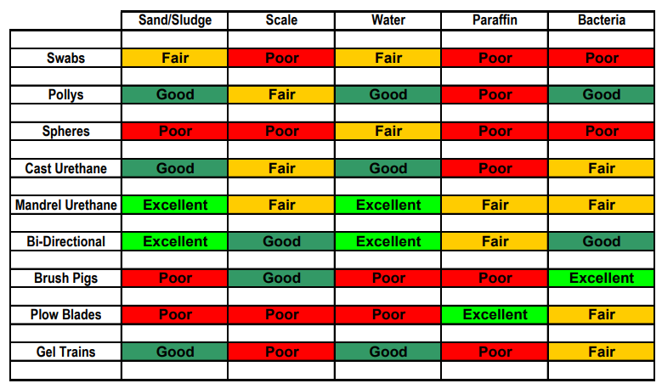
Table 1: Guidance for pig selection

4.0 Reuse of Pig Discs:
Normally it is discouraged to reuse a pig sealing disc that has run for more than 200km. Wherever Pig sealing and guide discs are reused the following conditions shall be strictly adhered to:
- There is no mark of damage or tear or loss of thickness and
- OD of the sealing disc and guide disc is at least 102% and 97% respectively, of the internal diameter or the pipeline (while calculating internal diameter of the pipeline only the normal wall thickness pipe is to be considered).

5.0 Pig residue collection and analysis:
- After every pigging pig residue shall be collected and quantity of residue received shall be recorded in a register and quantity received shall be compared to previous data. Residue collected after pigging to be sent for testing at a laboratory.
- Once in 6 months MIC testing shall be done. All test data shall be recorded in a manner that comparison of each of the component tested previously (from earlier pigging) can be easily carried out. Any abnormal variation in quantity/parameter of any tested component in consecutive runs shall be thoroughly analysed at unit/ base/ regional level by Operation Dept along with Maintenance Dept. Abnormal variation of any parameter to be brought to the notice of PL HO Maintenance and Inspection Dept.
Table 2: Test Parameters for pigging debris
Chemical test | Microbial test
1. pH | 1. Total Bacterial Counts (TBC)
2. % Water | 2. Sulfate Reducing Bacteria (SRB)
3. %Fe | 3. Iron Oxidizing Bacteria (IOB)
4. Chloride (ppm) | 4. Acid Producing Bacteria (APB)
5. Sulfide (ppm) as Sulfur
6. Sulfate (ppm)
7. Fe2O3 (%)
8. Si (%)

- Following additional tests shall be done at least once in a year as per advice of Inspection department (PLHO / Regional Office):

XRD Analysis | Onsite Testing
1. EDXA and XRD analysis | 1. pH
 | 2. Carbonate and Sulfide

SAFETY PROTOCOLS:
Following Safety Protocol to be adhered during execution of work.
- Necessary work permit to be obtained from control room for conducting the job.
- Required PPEs in line with PPE Matrix to be ensured during execution of job.
- Job Safety Analysis to be carried out and ensure its compliance during execution of job.
- Toolbox talk to be conducted prior start of job.
Site Engineer / Maintenance engineer or designated site representative must ensure site restoration upon completion of work.
********

